

**Project proposal (Synopsis) of**

**MASTER OF COMPUTER APPLICATION (MCA_NEW)**

**ON**

**Visitors Management System with Face Detection**

**Submitted By:**

**Mohd Nadeem**

**Enrolment no.: - 2301344556**

**Under Guidance**

**of**

**Faraz Khan**

**Submitted to:**

**Project Co-ordinator (MCA)**

**School of Computer and Information Sciences**

**Indira Gandhi National Open University**

**Maidan Garhi, New Delhi – 110068.**



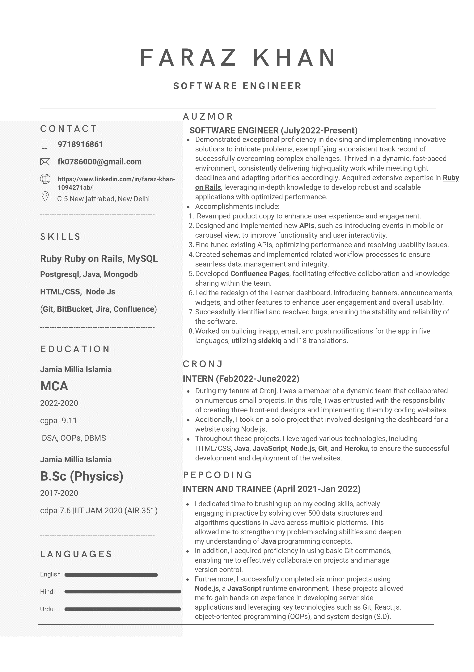

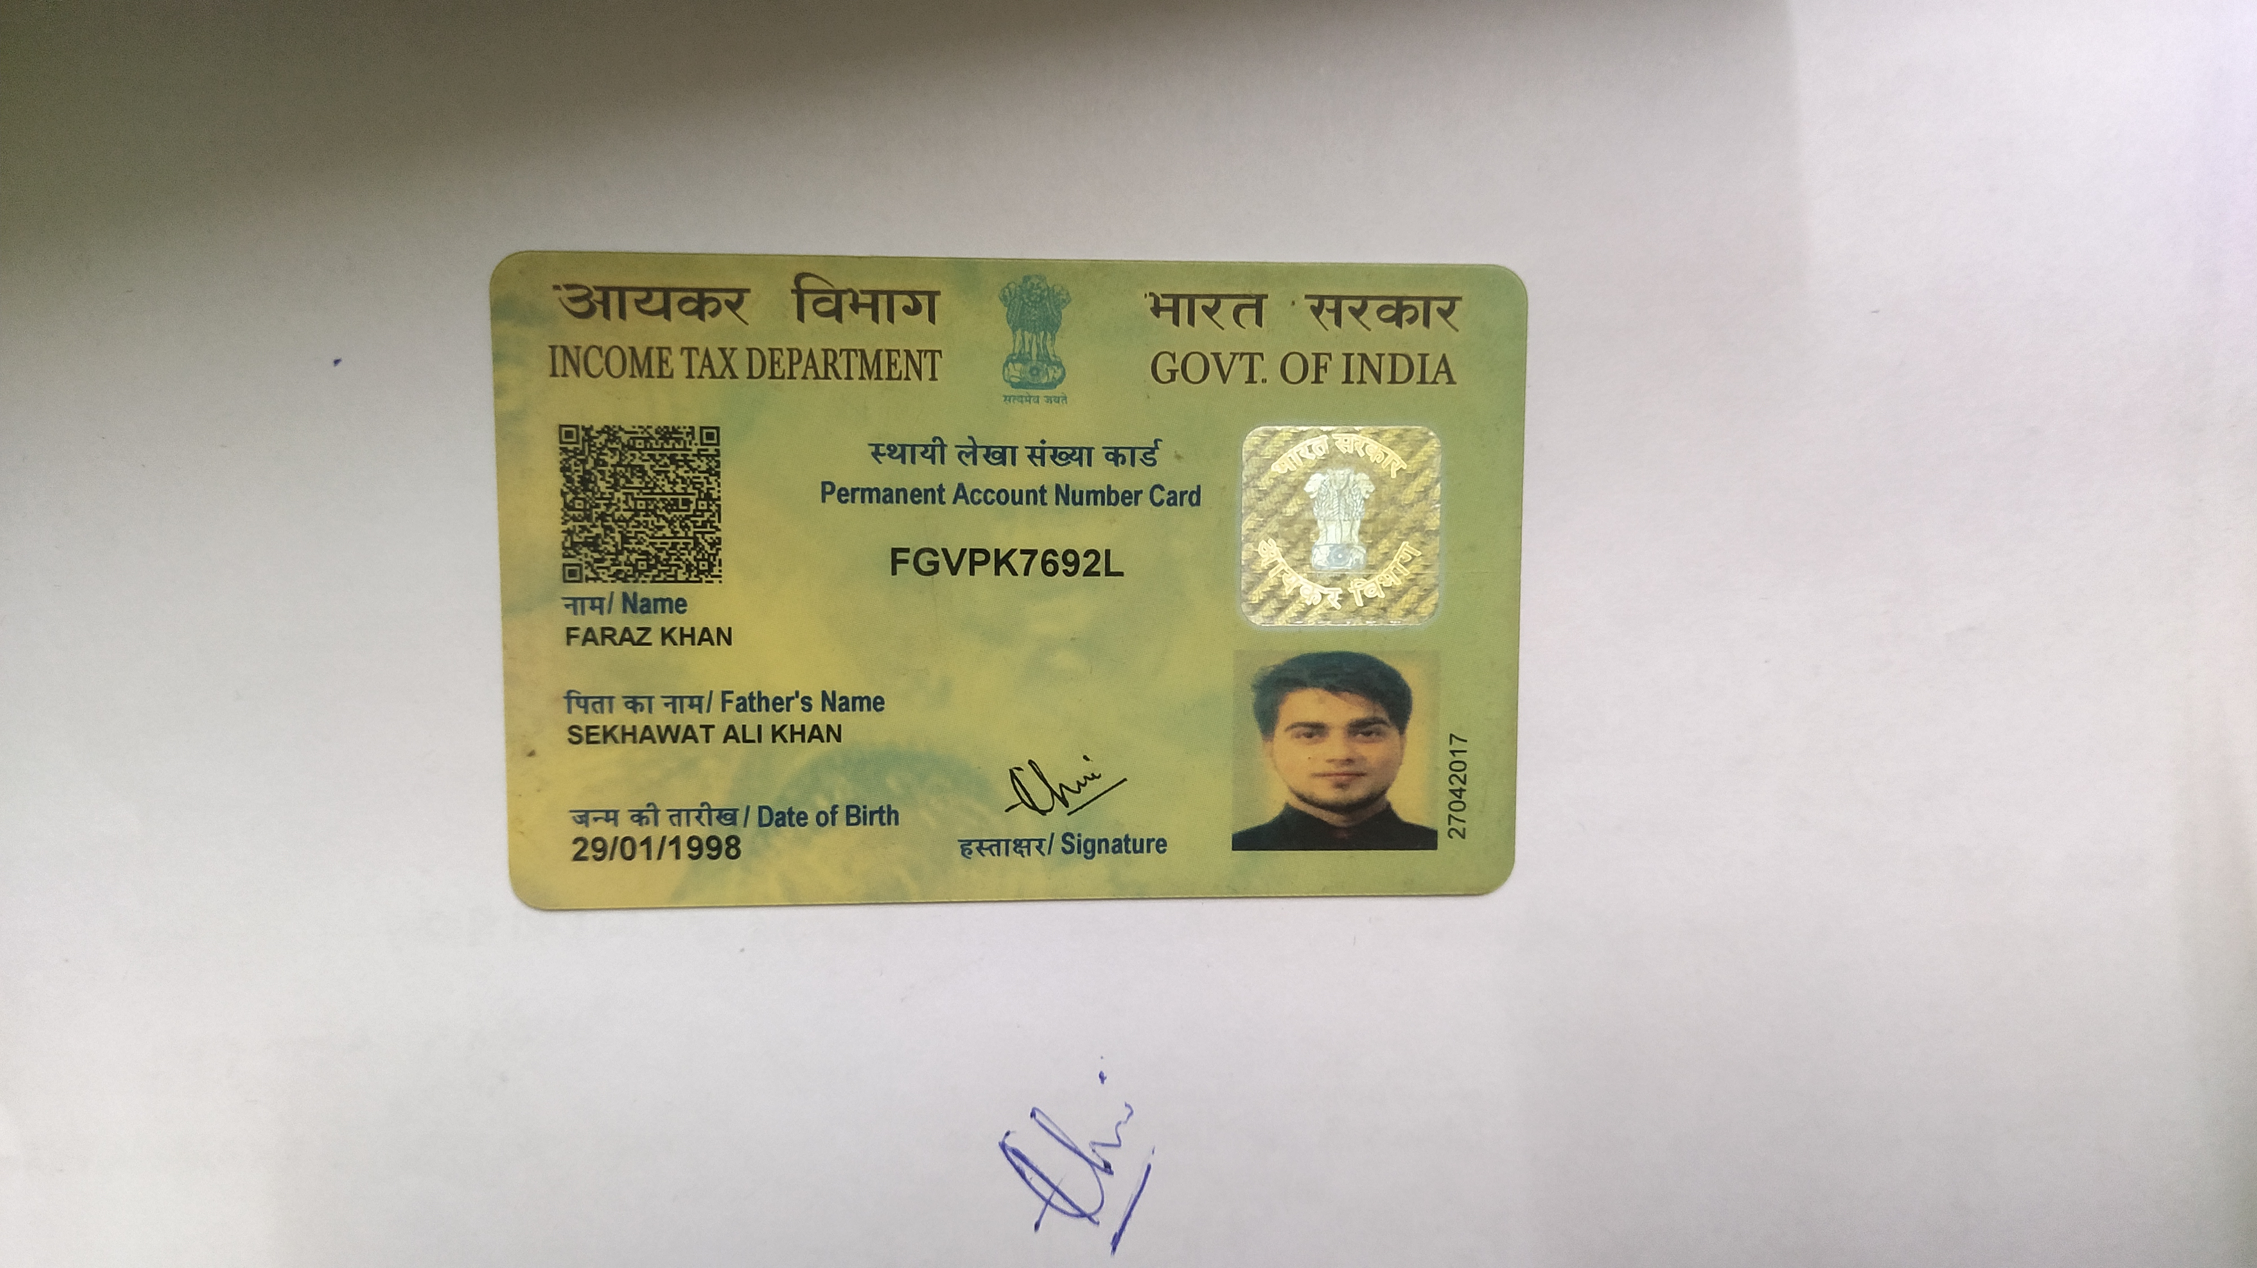



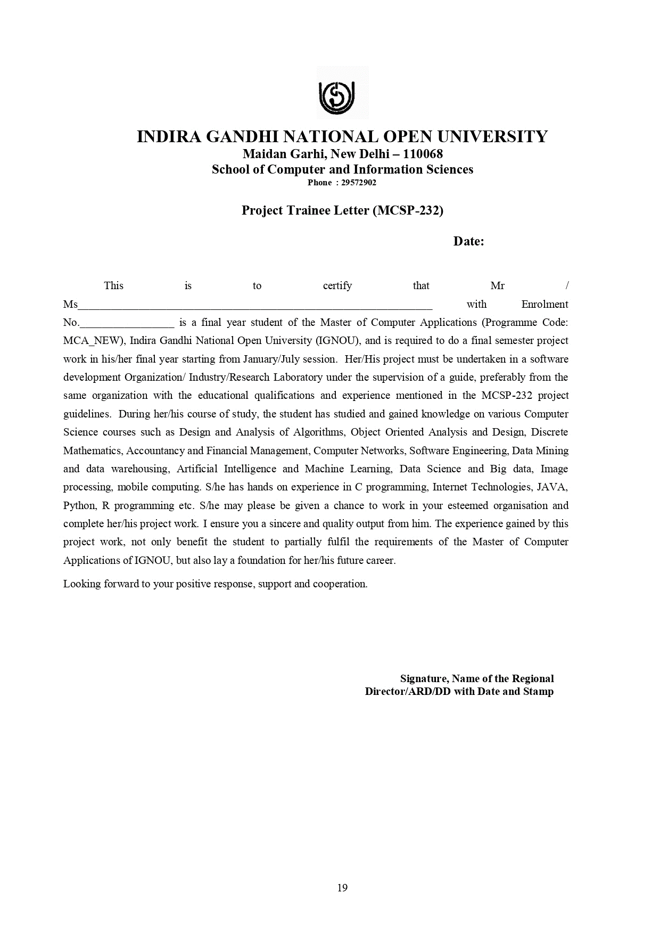

**Visitors Management System with Face Detection**

Enhancing Security Measures through Automated Identity Verification

**Author: -Mohd Nadeem**

**TABLE OF CONTENT**

|  |  |  |
| --- | --- | --- |
| S.NO. | TOPIC | PAGE NO. |
| 1 | **Introduction of Project** | **9** |
| 2 | **Objectives of Project** | **10** |
| 3 | **Project Category** | **12** |
| 4 | **Tools/Platform of Project, H/W and S/W requirements** | **14** |
| 5 | **Scope of the Solution** | **15** |
| 6 | **Analysis** | **16** |
| 7 | **Database and Tables** | **18** |
| 8 | **Structure and Implementation Details** | **20** |
| 9 | **Overall Network Architecture** | **23** |
| 10 | **Implementation of Security Mechanisms at Various Levels** | **25** |
| 11 | **Future scope and further enhancement of the project.** | **27** |
| 12 | **Bibliography** | **30** |

1. **Introduction**

In recent years, the proliferation of residential complexes, gated communities, and private societies has underscored the need for robust security and efficient management of visitor access. Traditional methods of manual verification and entry logging are increasingly inadequate in ensuring the safety and convenience of residents. Recognizing these challenges, the Facial Recognition Based Entry Management System seeks to innovate and transform how private societies handle visitor management through the integration of advanced facial recognition technology and sophisticated database management.

Private societies, often comprising high-density residential areas or exclusive communities, face unique security concerns. These range from unauthorized access and intrusions to the inconvenience caused by inefficient visitor processing. Current systems rely heavily on physical security measures and manual verification processes, which are not only prone to human error but also struggle to maintain pace with the growing complexities of modern residential environments.

The adoption of facial recognition technology represents a paradigm shift in entry management systems for private societies. By leveraging computer vision algorithms and machine learning models, the system aims to accurately identify and verify individuals approaching entry points. This technology offers several advantages over traditional methods, including enhanced accuracy, speed of verification, and the ability to maintain a comprehensive database of resident and visitor interactions.

1. **Objectives of Project**

The primary objective of this project is to develop an automated and secure entry management system tailored specifically for private societies. The system will leverage state-of-the-art facial recognition technology integrated with a relational database to enhance security, streamline visitor management, and improve overall operational efficiency. The specific objectives include:

1. **Implement Facial Recognition Technology:** Integrate computer vision techniques, particularly OpenCV, to develop a reliable facial recognition system. This system will accurately identify and verify individuals approaching the entry points of the society.
2. **Database Management:** Design and implement a PostgreSQL database to store comprehensive information about residents and visitors. This includes personal details, residency status (rental or owned), and entry/exit logs.
3. **Automate Entry Processes:** Automate the visitor entry process by capturing and analysing facial images in real-time. Upon identification, the system will grant access and log entry times seamlessly.
4. **Admin Interface for Manual Approval:** Develop an intuitive web-based admin interface using Flask and JavaScript. Admins will have the capability to manually approve entry requests for unrecognized visitors, ensuring stringent security protocols are maintained.
5. **Enhance Visitor Management:** Facilitate efficient visitor management by recording visit purposes, destination addresses within the society, and resident validation. This will streamline the approval process and provide residents with enhanced control over visitor access.
6. **Ensure Scalability and Adaptability:** Design the system to be scalable, capable of handling growing resident populations and visitor traffic. Additionally, ensure adaptability to different private society configurations and entry points.
7. **Implement Security Measures:** Implement robust security measures, including data encryption, secure transmission protocols (HTTPS), and role-based access control (RBAC) for admin functionalities. This ensures the protection of sensitive resident and visitor information.
8. **Future Enhancements:** Lay the groundwork for future enhancements, such as integration with access control systems, mobile applications for visitor pre-registration, and real-time notifications for residents and admins.

**Significance of the Project**

The Facial Recognition Based Entry Management System represents a significant advancement in residential security and operational efficiency for private societies. By leveraging cutting-edge technology and best practices in database management, the system aims to:

* Mitigate security risks associated with unauthorized access.
* Improve resident satisfaction by facilitating seamless and secure visitor entry.
* Provide admins with tools to efficiently manage and monitor visitor traffic.

1. **Project Category**

The Facial Recognition Based Entry Management System falls under several interconnected project categories, each contributing to its multifaceted approach in enhancing security, efficiency, and user experience within private societies.

**Artificial Intelligence (AI)**

At its core, the project leverages Artificial Intelligence (AI) through advanced facial recognition technology. AI algorithms, integrated with OpenCV and deep learning frameworks, enable the system to autonomously capture, process, and analyze facial features in real-time. This capability empowers the system to accurately verify visitor identities against a database, making informed decisions on access permissions without human intervention in routine cases.

Image Processing

Image processing forms a crucial component of the project, facilitating the extraction of meaningful data from captured facial images. Techniques such as image enhancement, segmentation, and feature extraction are employed to isolate and analyze facial characteristics essential for accurate recognition. These processes ensure that the system operates effectively across varying lighting conditions, angles, and facial expressions, thereby enhancing its reliability in real-world scenarios.

**Database Management**

Central to the project's operational framework is robust Database Management, categorized under Relational Database Management Systems (RDBMS). PostgreSQL is utilized to store and manage comprehensive visitor data, including personal details, residency status, visit histories, and access logs. The database architecture supports efficient data retrieval, storage, and manipulation, ensuring seamless integration with the facial recognition and visitor management modules. This structured approach not only enhances system scalability but also facilitates secure and organized data handling, crucial for regulatory compliance and data privacy.

**Web Development (Flask, HTML/CSS/JavaScript)**

The project incorporates Web Development methodologies to create an intuitive and interactive user interface using Flask, HTML, CSS, and JavaScript. The web-based admin interface allows authorized personnel to monitor visitor traffic, manage access permissions, and oversee entry logs in real-time. This component ensures user accessibility, system responsiveness, and seamless integration with backend functionalities, enhancing overall system usability and administrative control.

**Security and Compliance**

Project initiatives encompass Security and Compliance measures to safeguard sensitive data and uphold privacy standards. Encryption protocols, secure transmission channels (HTTPS), and role-based access control (RBAC) mechanisms are implemented to protect visitor information and administrative functionalities from unauthorized access and cyber threats. Compliance with data protection regulations, such as GDPR, ensures ethical and lawful handling of personal data, fostering trust among residents and stakeholders.

1. **Tools/Platform, Hardware and Software Requirement Specifications**
2. **Web Development:**
   * **Framework:** Flask 2.0.1 (latest version)
   * **Frontend:** HTML5, CSS3, JavaScript (ES6)
3. **Database Management System:**
   * **RDBMS:** PostgreSQL 14.0 (latest version)
   * **Database Connectivity:** psycopg2 2.9.2 (Python PostgreSQL adapter)
4. **Image Processing:**
   * **Library:** OpenCV 4.5.3 (latest version)
   * **Deep Learning Framework:** TensorFlow 2.7.0 with Keras 2.8.0 backend (latest versions)
5. **Version Control:**
   * Git 2.35.1 (latest version)
   * GitHub for version control and collaboration
6. **IDE:**
   * Visual Studio Code 1.65.2 (latest version) for development

**Hardware Requirements**

* **Camera:** High-resolution IP camera capable of capturing clear facial images.
* **Server:** Minimum Intel Core i5 processor, 8GB RAM, and sufficient storage for database and application files.
* **Network:** Stable internet connection for real-time data processing and remote access.

1. **Scope of the Solution**

The Facial Recognition Based Entry Management System aims to streamline visitor management in private societies through automated access control and robust security measures. Utilizing advanced facial recognition technology integrated with a PostgreSQL database, the system ensures real-time identification and verification of visitors, enhancing security by minimizing unauthorized access and operational efficiency by reducing reliance on manual processes. Administrators will access a user-friendly web interface to oversee entry logs, manage permissions, and update resident information, facilitating seamless communication and effective visitor handling. The system's scalability supports future enhancements like mobile apps for pre-registration and AI-driven analytics, ensuring adaptability to evolving security needs and technological advancements while maintaining robust residential security standards.

Looking ahead, the Facial Recognition Based Entry Management System holds promising avenues for future development and enhancement. Potential expansions include integrating AI for predictive visitor behaviour analysis, enhancing user experience with mobile applications for visitor pre-registration and real-time notifications, and implementing IoT solutions for smart access control. These advancements aim to further optimize security measures, improve operational efficiency, and accommodate evolving technological landscapes within private societies. By continuously innovating and adapting, the system strives to uphold its commitment to providing cutting-edge solutions for secure and efficient visitor management in residential environments.

1. **Analysis**

**ER Diagram (Entity-Relationship Diagram)**

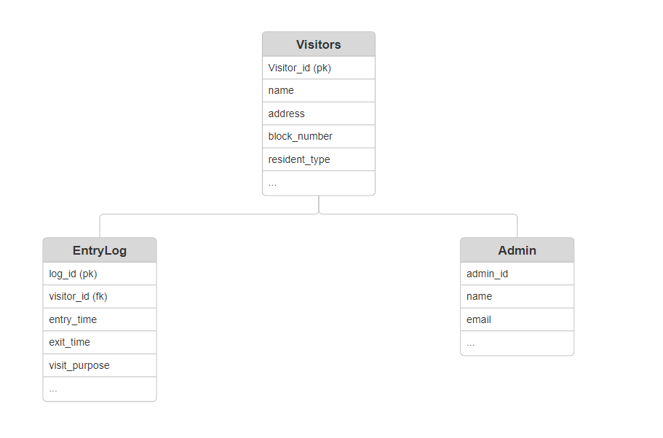The ER diagram depicts the relationships between entities involved in the system:

**Activity Diagram**

The activity diagram outlines the workflow of visitor entry and approval processes:

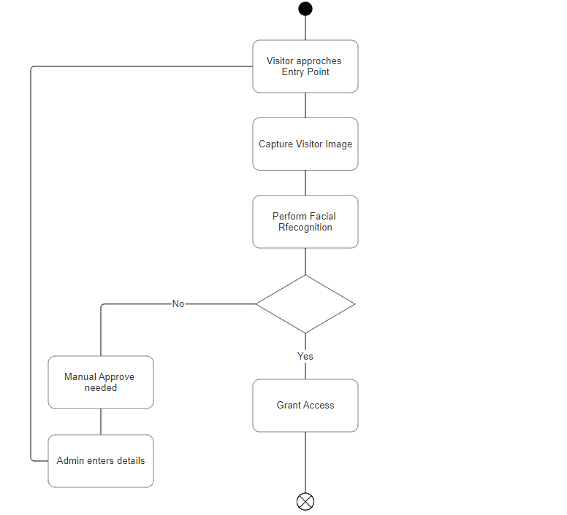

1. **Database and Tables Detail**

**Visitors Table**

|  |  |  |  |
| --- | --- | --- | --- |
| Column Name | Type | Constraint | Description |
| visitor_id | UUID | PRIMARY KEY | Unique identifier for each visitor |
| name | VARCHAR(100) | NOT NULL | Name of the visitor |
| address | VARCHAR(255) | NOT NULL | Address of the visitor |
| block_no | VARCHAR(10) | NOT NULL | Block number where the visitor resides or visits |
| resident_type | VARCHAR(10) | NOT NULL | Type of resident (e.g., rental, owned) |
| image | BYTEA | NOT NULL | Binary data of the visitor's image |

**Admins Table**

|  |  |  |  |
| --- | --- | --- | --- |
| Column Name | Type | Constraint | Description |
| admin_id | UUID | PRIMARY KEY | Unique identifier for each admin |
| name | VARCHAR(100) | NOT NULL | Name of the admin |
| email | VARCHAR(100) | UNIQUE, NOT NULL | Email address of the admin |
| password | VARCHAR(255) | NOT NULL | Encrypted password for admin authentication |

**Entry Logs Table**

|  |  |  |  |
| --- | --- | --- | --- |
| Column Name | Type | Constraint | Description |
| log_id | UUID | PRIMARY KEY | Unique identifier for each entry log |
| visitor_id | UUID | FOREIGN KEY | References the visitor_id in the visitors table |
| entry_time | TIMESTAMP | NOT NULL | Time of entry |
| exit_time | TIMESTAMP |  | Time of exit |
| visit_type | VARCHAR(50) |  | Type of visit (e.g., guest, service) |
| destination | VARCHAR(255) |  | Address and block number of the destination |
| admin_approved | BOOLEAN | NOT NULL, DEFAULT FALSE | Indicates if the entry was manually approved by an admin |

1. **Structure and Implementation Details**

The Facial Recognition Based Entry Management System is structured into multiple modules, each performing specific functions to ensure smooth operation and robust security for the private society. Below are the details of the project structure, including module descriptions, data structures, process logic, implementation methodology, and list of reports generated.

**Number of Modules and Their Description**

1. **User Interface Module**:
   * **Description**: This module handles the web-based user interface for both admins and visitors. It includes login pages, visitor entry forms, and admin dashboards.
   * **Process Logic**: Displays forms for data entry and processes user inputs, providing feedback and updates to the user.
2. **Facial Recognition Module**:
   * **Description**: This module captures and processes visitor images using a camera. It performs facial recognition to match captured images against stored images in the database.
   * **Process Logic**: Uses OpenCV and deep learning models to detect and recognize faces. If a match is found, it proceeds with the entry process; otherwise, it requests manual approval.
3. **Database Management Module**:
   * **Description**: This module manages all database interactions, including storing and retrieving visitor details, images, and entry logs.
   * **Process Logic**: Implements SQL queries to perform CRUD operations on the PostgreSQL database.
4. **Admin Approval Module**:
   * **Description**: This module allows admins to manually approve visitor entries when facial recognition fails to find a match.
   * **Process Logic**: Provides an interface for admins to review visitor details and approve or deny access. Approved entries are recorded in the database.
5. **Logging and Reporting Module**:
   * **Description**: This module records all entry and exit logs and generates reports based on the recorded data.
   * **Process Logic**: Implements SQL queries to generate reports on visitor entries and exits, including timestamps and visit purposes.

**Data Structures**

* **Visitors Table**: Stores visitor details, including images.
* **Admins Table**: Stores admin credentials and information.
* **Entry Logs Table**: Records entry and exit details.
* **Images Table**: Stores binary data of visitor images.

**Process Logic of Each Module**

1. **User Interface Module**:
   * **Login**: Validates user credentials.
   * **Data Entry**: Collects and validates visitor information.
   * **Feedback**: Provides confirmation or error messages to users.
2. **Facial Recognition Module**:
   * **Capture Image**: Uses the camera to capture the visitor's image.
   * **Match Image**: Compares the captured image with stored images.
   * **Result Processing**: Proceeds with entry if a match is found; otherwise, requests admin approval.
3. **Database Management Module**:
   * **CRUD Operations**: Executes SQL queries to create, read, update, and delete records in the database.
   * **Image Storage**: Saves and retrieves images as binary data.
4. **Admin Approval Module**:
   * **Review Requests**: Displays pending approval requests to admins.
   * **Approve/Deny**: Allows admins to approve or deny entry requests.
   * **Record Entry**: Updates the entry log upon approval.
5. **Logging and Reporting Module**:
   * **Record Logs**: Inserts entry and exit records into the database.
   * **Generate Reports**: Creates reports on visitor activity based on specified criteria.

**Implementation Methodology**

* **Development**: The system will be developed using Flask for the backend, PostgreSQL for the database, and HTML, CSS, and JavaScript for the frontend.
* **Integration**: Modules will be integrated to work seamlessly, ensuring data flows correctly between the user interface, facial recognition, and database.
* **Testing**: Each module will undergo rigorous testing to ensure functionality, performance, and security.
* **Deployment**: The system will be deployed on a server, with continuous monitoring and maintenance to ensure smooth operation.

**List of Reports Generated**

1. **Daily Entry Log Report**: A report listing all entries and exits for a particular day.
2. **Visitor Activity Report**: A report detailing the activities of a specific visitor over a period.
3. **Admin Approval Report**: A report showing entries that required manual approval, including the reasons and outcomes.
4. **Unrecognized Visitor Report**: A report listing all visitors who were not recognized by the facial recognition system and required manual approval.
5. **Overall Network Architecture**

The network architecture for the Facial Recognition Based Entry Management System is designed to ensure secure, efficient, and reliable communication between various components of the system. The architecture includes hardware, software, and networking components that work together to provide a seamless user experience. Below is a detailed description of the overall network architecture.

#### **Components of the Network Architecture**

1. **Client Devices**
   * **Description**: Devices used by admins and visitors to interact with the system.
   * **Examples**: Desktop computers, laptops, tablets, and smartphones.
   * **Functionality**: Admins use these devices to access the web-based interface for managing entries, while visitors might use them to input their information.
2. **Cameras**
   * **Description**: Cameras installed at entry points to capture images of visitors.
   * **Examples**: IP cameras, USB cameras.
   * **Functionality**: Captures real-time images of visitors for facial recognition.
3. **Web Server**
   * **Description**: The server hosting the web application built using Flask.
   * **Functionality**: Handles HTTP requests, serves web pages, and processes backend logic.
4. **Database Server**
   * **Description**: The server hosting the PostgreSQL database.
   * **Functionality**: Stores and manages all data related to visitors, admins, images, and entry logs.
5. **Facial Recognition Server**
   * **Description**: The server dedicated to running the facial recognition algorithms.
   * **Functionality**: Processes images captured by cameras to identify visitors.
6. **Network Infrastructure**
   * **Description**: The networking components that connect all devices and servers.
   * **Examples**: Routers, switches, firewalls.
   * **Functionality**: Ensures secure and efficient communication between all components.

#### **Communication Flow**

1. **Visitor Entry Process**
   * **Step 1**: A visitor approaches the entry point, and the camera captures their image.
   * **Step 2**: The captured image is sent to the Facial Recognition Server over the network.
   * **Step 3**: The Facial Recognition Server processes the image and checks it against the database.
   * **Step 4**: If a match is found, the entry is logged in the database, and the visitor is granted access. If no match is found, an alert is sent to the admin for manual approval.
   * **Step 5**: Admins use client devices to review and approve or deny the entry request.
2. **Admin Approval Process**
   * **Step 1**: Admin receives an alert on their device about an unrecognized visitor.
   * **Step 2**: Admin logs into the web application to review visitor details and captured images.
   * **Step 3**: Admin approves or denies the entry request. If approved, the visitor's details are recorded in the database.
3. **Data Storage and Retrieval**
   * **Step 1**: The web server communicates with the database server to store and retrieve visitor details, images, and entry logs.
   * **Step 2**: All data exchanges between the web server, database server, and client devices are encrypted to ensure security.
4. **Implementation of Security Mechanisms at Various Levels**

Security is a critical aspect of the Facial Recognition Based Entry Management System, given the sensitivity of the data involved, including personal information and images. The system employs multiple layers of security mechanisms to ensure data integrity, confidentiality, and availability. The security measures are implemented at various levels, including network security, application security, and data security.

#### **1. Network Security**

* **Encryption in Transit**: All data transmitted over the network between client devices, servers, and cameras is encrypted using SSL/TLS protocols. This ensures that any data intercepted during transmission is unreadable to unauthorized parties.
* **Firewalls**: Firewalls are deployed to protect the internal network from unauthorized access and potential cyber threats. They monitor and control incoming and outgoing network traffic based on predetermined security rules.
* **Virtual Private Network (VPN)**: A VPN can be used to secure remote connections to the system, ensuring that all data transmitted over the public internet is encrypted and secure.

#### **2. Application Security**

* **Authentication**: The system employs strong authentication mechanisms to verify the identities of users (admins and visitors). This includes:
  + **Password Policies**: Enforcing strong password policies (e.g., minimum length, complexity requirements) and periodic password changes.
  + **Two-Factor Authentication (2FA)**: Adding an extra layer of security by requiring a second form of verification in addition to the password.
* **Authorization**: Role-based access control (RBAC) is implemented to ensure that users have access only to the resources and operations that are necessary for their roles. For instance, only admins can approve visitor entries and manage user data.
* **Session Management**: Secure session management practices are implemented, including:
  + **Session Timeout**: Automatically logging out users after a period of inactivity.
  + **Secure Cookies**: Using secure and HttpOnly flags for cookies to prevent client-side access and cross-site scripting (XSS) attacks.
* **Input Validation and Sanitization**: All user inputs are validated and sanitized to prevent common web vulnerabilities such as SQL injection, cross-site scripting (XSS), and cross-site request forgery (CSRF).

#### **3. Data Security**

* **Encryption at Rest**: Sensitive data, including personal details and images stored in the database, are encrypted using strong encryption algorithms (e.g., AES-256). This ensures that even if the database is compromised, the data remains protected.
* **Access Controls**: Strict access controls are enforced at the database level to ensure that only authorized users and applications can access or modify the data.
* **Data Masking and Anonymization**: Where applicable, data masking and anonymization techniques are used to protect sensitive information, especially when used in non-production environments such as development and testing.

#### **4. Security Monitoring and Incident Response**

* **Logging and Monitoring**: All access and activity within the system are logged. Logs are monitored for suspicious activities, and anomaly detection techniques are employed to identify potential security incidents.
* **Intrusion Detection and Prevention Systems (IDPS)**: IDPS are deployed to monitor network traffic and system activities for signs of malicious behavior, providing alerts and taking preventive measures when threats are detected.
* **Incident Response Plan**: A comprehensive incident response plan is in place to quickly address and mitigate the impact of any security breaches. This includes predefined procedures for identification, containment, eradication, recovery, and post-incident analysis.

#### **5. Regular Security Audits and Updates**

* **Vulnerability Assessments and Penetration Testing**: Regular vulnerability assessments and penetration testing are conducted to identify and address security weaknesses in the system.
* **Software Updates and Patch Management**: Keeping all software components up to date with the latest security patches and updates is crucial. This includes the operating system, web server, database, and all libraries and dependencies used in the application.

1. **Future scope and further enhancement of the project**

The Facial Recognition Based Entry Management System has significant potential for future growth and enhancement, providing opportunities to increase its functionality, improve user experience, and enhance security. Below are some of the possible future enhancements and expansions:

#### **1. Integration with Additional Security Systems**

* **Biometric Authentication**: Integrate other biometric authentication methods such as fingerprint scanning or iris recognition to complement facial recognition, providing a multi-factor authentication approach.
* **RFID and NFC Integration**: Incorporate RFID (Radio Frequency Identification) and NFC (Near Field Communication) technologies for access control, allowing for seamless entry using RFID cards or NFC-enabled devices.
* **Surveillance System Integration**: Integrate with existing CCTV surveillance systems for continuous monitoring and recording, enabling real-time alerts and recording of all entry and exit activities.

#### **2. Mobile Application Development**

* **Admin Mobile App**: Develop a mobile application for admins, allowing them to approve or deny entry requests, monitor visitor logs, and manage user data remotely.
* **Visitor Mobile App**: Create a mobile app for residents and frequent visitors to pre-register their visits, receive notifications on approvals, and access their entry/exit history.

#### **3. Advanced Facial Recognition Features**

* **Real-Time Recognition**: Enhance the system to provide real-time facial recognition, reducing the time taken to process entries and improving overall efficiency.
* **Emotion Detection**: Integrate emotion detection capabilities to identify and record the emotional state of visitors, which can be useful for security and service improvement purposes.
* **Age and Gender Recognition**: Implement features to detect and record the age and gender of visitors, providing additional data points for security and analytics.

#### **4. Enhanced Reporting and Analytics**

* **Advanced Reporting**: Develop advanced reporting tools that allow for customizable reports, trend analysis, and predictive analytics. This could help in identifying patterns and making data-driven decisions.
* **Visitor Insights**: Provide detailed insights into visitor behavior, such as peak visiting times, frequent visitors, and visitor demographics.
* **Security Alerts and Notifications**: Implement automated security alerts and notifications for suspicious activities or failed recognition attempts, allowing for immediate response and action.

#### **5. Scalability and Performance Improvements**

* **Distributed Architecture**: Transition to a distributed system architecture to handle a larger number of simultaneous users and improve system performance.
* **Cloud Integration**: Integrate with cloud services to provide scalable storage solutions, backup, and disaster recovery options, ensuring data integrity and availability.
* **Load Balancing**: Implement load balancing techniques to distribute traffic evenly across servers, enhancing system reliability and performance.

#### **6. User Experience Enhancements**

* **User-Friendly Interface**: Continuously improve the user interface to make it more intuitive and user-friendly, ensuring ease of use for both admins and visitors.
* **Multilingual Support**: Add support for multiple languages to cater to a diverse user base, improving accessibility and user experience.
* **Accessibility Features**: Incorporate accessibility features to ensure that the system is usable by individuals with disabilities, adhering to global accessibility standards.

#### **7. Compliance and Data Privacy**

* **GDPR Compliance**: Ensure that the system complies with GDPR (General Data Protection Regulation) and other relevant data privacy regulations, safeguarding user data and ensuring legal compliance.
* **Data Anonymization**: Implement data anonymization techniques to protect the identities of individuals in reports and analytics, further enhancing data privacy.
* **Regular Security Audits**: Conduct regular security audits and vulnerability assessments to identify and address potential security risks, maintaining a high level of security.

1. **Bibliography**

**Websites**

1. <https://www.google.com/>
2. <https://www.postgresql.org/>
3. <https://opencv.org/>
4. <https://www.w3schools.com/>

**Papers**

1. Viola-Jones Object Detection Framework: A Case Study in Face Detection
2. An Overview of the Security and Privacy Issues in Face Recognition Technologies
3. Using PostgreSQL in Web Applications: A Comparative Study by T. Grust, J. Rittinger

**Books**

1. **"Deep Learning"** by Ian Goodfellow, Yoshua Bengio, and Aaron Courville
2. **"Hands-On Machine Learning with Scikit-Learn, Keras, and TensorFlow"** by Aurélien Géron
3. **"Flask Web Development: Developing Web Applications with Python"** by Miguel Grinberg
4. **IGNOU blocks**